**Name - Gaurang A Raorane Roll No - 49**

**Class - D15A Batch - C**

**EXPERIMENT NO - 5**

**Aim:Experiment to study the basics of Java Script.**

**Theory:-**

JavaScript is a widely used programming language for web development. It allows web developers to add interactivity and dynamic behavior to websites, making them more engaging and responsive to user input. JavaScript is a client-side scripting language, which means it runs on the user's web browser, allowing for real-time manipulation of web page content without requiring server-side processing.

**Key Concepts in JavaScript**:

* **Variables and Data Types:** JavaScript allows the declaration of variables to store different types of data, including numbers, strings, and booleans. Understanding data types and how to declare variables is crucial in programming with JavaScript.
* **Control Structures:** JavaScript provides control structures like conditional statements (if, else if, else) and loops (for, while) that enable developers to create logic and decision-making processes within their scripts.
* **Functions**: Functions are blocks of reusable code that can be defined and called to perform specific tasks. In JavaScript, functions are essential for modular programming and code reusability.
* **Events**: JavaScript can be used to respond to user interactions with web pages. Events, such as clicks, mouse movements, and keyboard inputs, can trigger JavaScript functions to create dynamic and interactive features on a website.
* **DOM Manipulation:** The Document Object Model (DOM) represents the structure of a web page. JavaScript can be used to manipulate the DOM, allowing developers to change content, style, and structure dynamically.
* **Arrays and Objects:** JavaScript supports arrays for storing and manipulating lists of data and objects for grouping related data and functions together. Understanding how to work with these data structures is crucial in web development.
* **Error Handling:** JavaScript allows for the handling of errors and exceptions. Students should learn how to write robust code that gracefully handles errors and avoids unexpected program crashes.
* **Debugging:** Debugging is an essential skill for any programmer. Students will learn how to use browser developer tools to identify and fix issues in their JavaScript code.

**Input:-**

<html>

<head>

<title>Menu-Driven Program</title>

</head>

<body>

<script>

// JavaScript code goes here

var choice = prompt("Enter your choice:\n1. Factorial\n2. Fibonacci\n3. Exit");

choice = parseInt(choice);

switch (choice) {

case 1:

var num = prompt("Enter a number");

num = parseInt(num);

var fact = 1;

for (var i = 1; i <= num; i++) {

fact = fact * i;

}

alert("Factorial of " + num + " is " + fact);

break;

case 2:

var fib = [];

fib[0] = 0;

fib[1] = 1;

for (var i = 2; i < 20; i++) {

fib[i] = fib[i - 1] + fib[i - 2];

}

alert("First 20 terms of Fibonacci series are:\n" + fib);

break;

case 3:

break;

default:

alert("Invalid choice");

}

</script>

</body>

</html>

**Output:-**

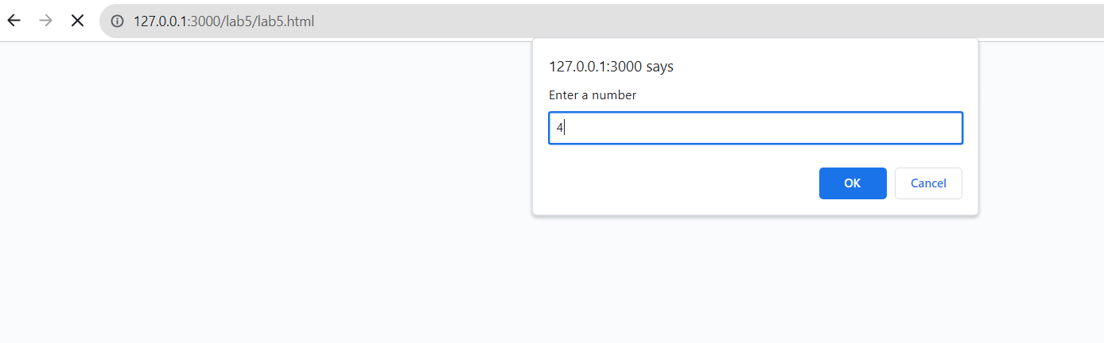

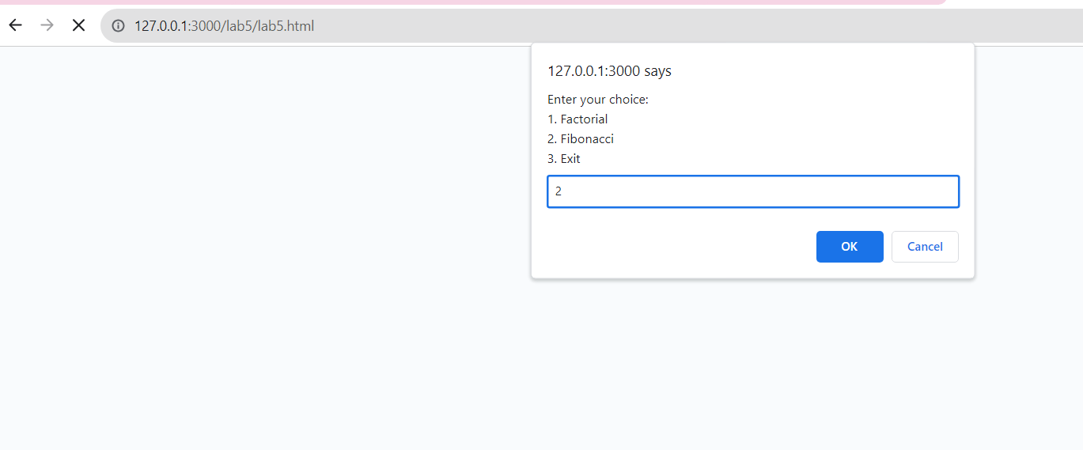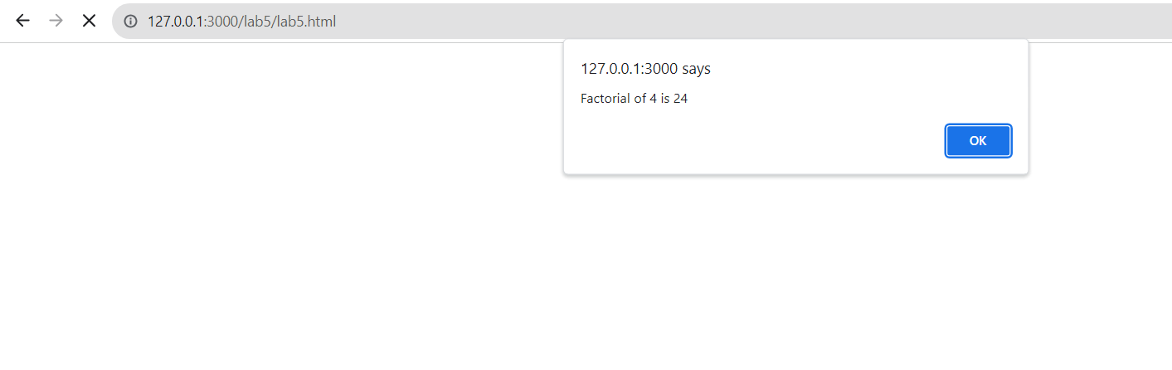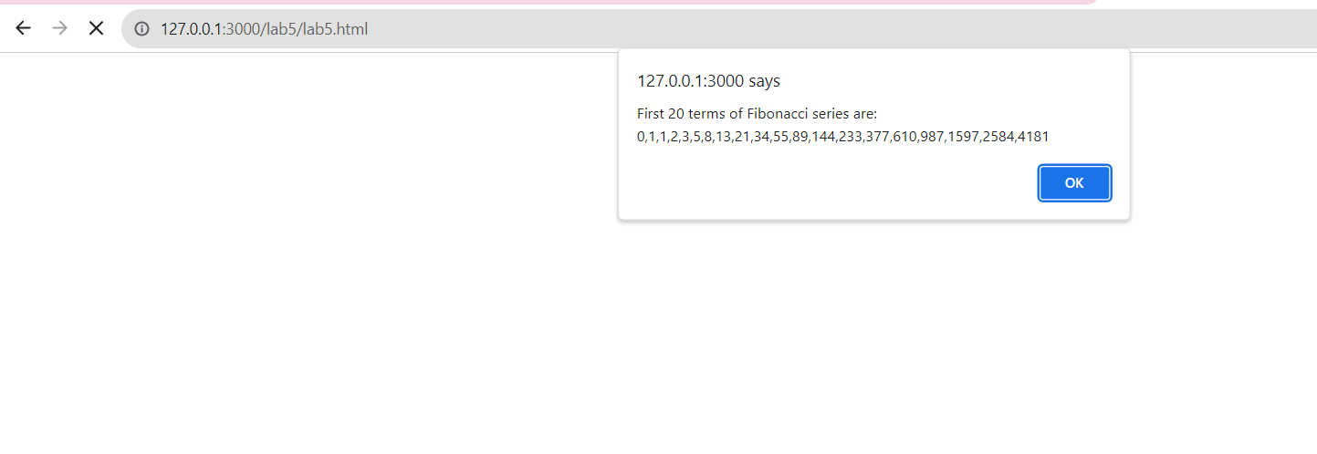

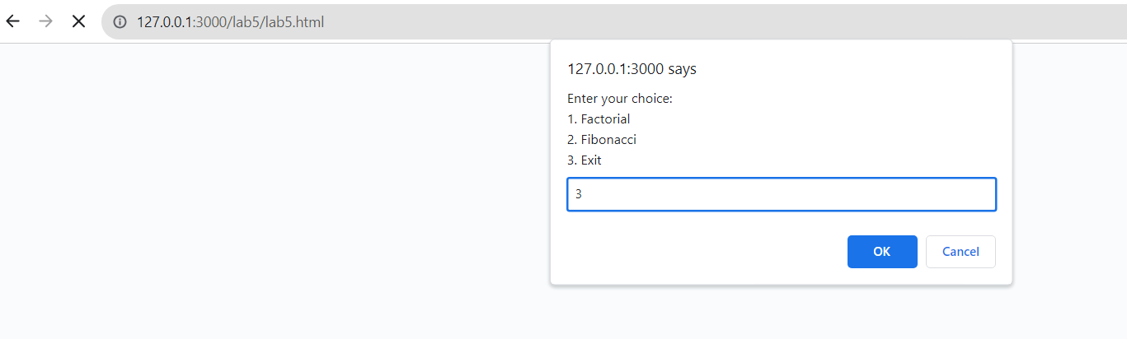

**Program to implement different arithmetic operations using function and Arrow function**

**Input:-**

<!DOCTYPE html>

<html>

<head>

<title>Arithmetic Operations</title>

</head>

<body>

<h1>Arithmetic Operations</h1>

<form id="calculator">

<label for="num1">Enter number 1:</label>

<input type="number" id="num1" required>

<br>

<label for="num2">Enter number 2:</label>

<input type="number" id="num2" required>

<br>

<label>Choose an operation:</label>

<select id="operation" required>

<option value="add">Addition</option>

<option value="subtract">Subtraction</option>

<option value="multiply">Multiplication</option>

<option value="divide">Division</option>

</select>

<br>

<button type="button" onclick="calculate()">Calculate</button>

</form>

<p id="result">Result: </p>

<script>

function calculate() {

const num1 = parseFloat(document.getElementById("num1").value);

const num2 = parseFloat(document.getElementById("num2").value);

const operation = document.getElementById("operation").value;

let result = 0;

if (operation === "add") {

result = addition(num1, num2);

} else if (operation === "subtract") {

result = subtraction(num1, num2);

} else if (operation === "multiply") {

result = multiplication(num1, num2);

} else if (operation === "divide") {

result = division(num1, num2);

}

document.getElementById("result").textContent = "Result: " + result;

}

// Regular Functions

function addition(a, b) {

return a + b;

}

function subtraction(a, b) {

return a - b;

}

function multiplication(a, b) {

return a * b;

}

function division(a, b) {

if (b !== 0) {

return a / b;

} else {

return "Cannot divide by zero";

}

}

</script>

</body>

</html>

